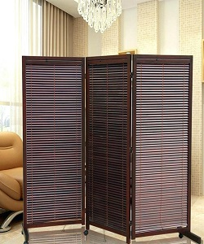

Durian 3 Panel Divider

$125.90

Availability: In stock

Description

Folding Screens Room Dividers with Caster Japanese Style Decorative Panel Screen Partition Wooden Dividers for Rooms High quality solid wood 3 panel screen room divider. Oriental Screens Room Wood Divider.